Ejercicio 1

SELECT fa.factura_id,
fa.fecha_emision,
cl.razon_social,
cl.pais,
un.nombre AS unidad,
cu.nombre AS cuenta,
fa.importe
FROM dbo.facturas AS fa
JOIN dbo.clientes AS cl ON cl.cliente_id = fa.cliente_id
JOIN dbo.unidades AS un ON un.unidad_id = fa.unidad_id
JOIN dbo.cuentas AS cu ON cu.cuenta_id = fa.cuenta_id
WHERE cl.pais <> 'ES'
AND fa.importe >= 80000
AND fa.fecha_emision BETWEEN '2026-07-01' AND '2026-09-30'
ORDER BY fa.importe DESC;

Resultado
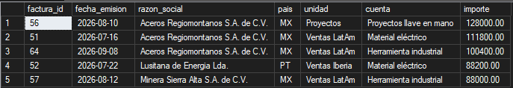

Ejercicio 2

select fa.factura_id ,cl.razon_social, fa.fecha_emision,fa.importe

from dbo.facturas as fa
join dbo.clientes as cl on cl.cliente_id = fa.cliente_id
where fa.importe > (SELECT AVG(fa.importe)*2 FROM facturas as fa)

order by fa.importe DESC;

resultado
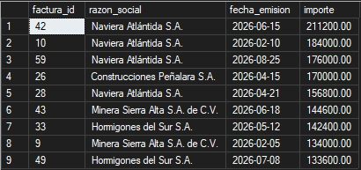

Ejercicio 3

select
c.metodo,count(c.cobro_id),sum(c.importe) AS importe

from dbo.cobros as c
WHERE factura_id IN (
SELECT factura_id FROM facturas
WHERE cliente_id IN (
SELECT cliente_id FROM clientes
WHERE gestor_id IN (
SELECT empleado_id FROM empleados as e
WHERE puesto = N'Comercial')))
group by c.metodo
order by importe desc;

resultado

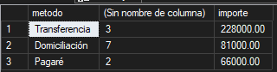

Ejercicio 4
WITH cobros_factura AS (
SELECT factura_id, SUM(importe) AS cobrado
FROM dbo.cobros
GROUP BY factura_id
)
SELECT f.factura_id,
cl.razon_social,
f.importe,
cf.cobrado,
(f.importe - cf.cobrado) AS pendiente
FROM dbo.facturas AS f
JOIN dbo.clientes AS cl ON cl.cliente_id = f.cliente_id
JOIN cobros_factura AS cf ON cf.factura_id = f.factura_id
WHERE cf.cobrado > 0
AND cf.cobrado < f.importe
ORDER BY pendiente DESC, f.factura_id ASC;

Resultado
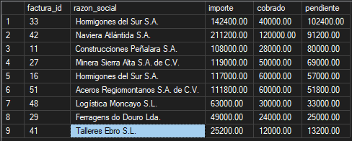

Ejercicio 5

WITH facturas_t3 AS (
SELECT factura_id, cliente_id, importe, fecha_emision
FROM dbo.facturas
WHERE fecha_emision BETWEEN '2026-07-01' AND '2026-09-30'
),
enriquecidas AS (
SELECT f.factura_id,
f.importe,
cli.pais,
cli.segmento
FROM facturas_t3 AS f
JOIN dbo.clientes AS cli ON cli.cliente_id = f.cliente_id
),
por_segmento AS (
SELECT pais,
segmento,
COUNT(factura_id) AS facturas,
SUM(importe) AS importe
FROM enriquecidas
GROUP BY pais, segmento
)
SELECT pais,
segmento,
facturas,
importe
FROM por_segmento
WHERE importe >= 200000
ORDER BY importe DESC;

Respuestas
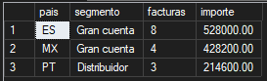

Ejercicio 6
WITH arbol_unidades AS (
-- Caso base
SELECT unidad_id,
nombre,
tipo,
0 AS nivel,
CAST(nombre AS nvarchar(500)) AS ruta
FROM dbo.unidades as u
WHERE u.unidad_padre_id IS NULL

UNION ALL

-- Caso recursivo
SELECT u.unidad_id,
u.nombre,
u.tipo,
a.nivel + 1,
CAST(a.ruta + N' > ' + u.nombre AS nvarchar(500))
FROM dbo.unidades AS u
JOIN arbol_unidades AS a ON u.unidad_padre_id = a.unidad_id
)
SELECT unidad_id,
nombre,
tipo,
nivel,
ruta
FROM arbol_unidades
ORDER BY ruta ASC;

Resultado

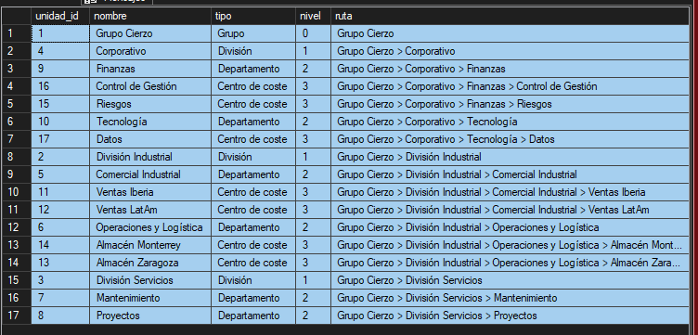

Ejercicio 7
CREATE OR ALTER VIEW dbo.vw_cuenta_resultados AS
SELECT p.ejercicio,
p.trimestre,
cu.tipo,
cu.nombre AS cuenta,
f.importe
FROM dbo.facturas AS f
JOIN dbo.cuentas AS cu ON cu.cuenta_id = f.cuenta_id
JOIN dbo.periodos AS p ON f.fecha_emision BETWEEN p.fecha_inicio AND p.fecha_fin

UNION ALL

SELECT p.ejercicio,
p.trimestre,
cu.tipo,
cu.nombre AS cuenta,
g.importe
FROM dbo.gastos AS g
JOIN dbo.cuentas AS cu ON cu.cuenta_id = g.cuenta_id
JOIN dbo.periodos AS p ON g.fecha BETWEEN p.fecha_inicio AND p.fecha_fin;

SELECT trimestre,
tipo,
SUM(importe) AS importe
FROM dbo.vw_cuenta_resultados
GROUP BY trimestre, tipo
ORDER BY trimestre ASC, tipo ASC;

Resultado
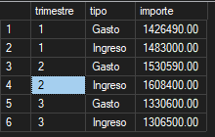

Ejercicio 8

CREATE OR ALTER VIEW dbo.vw_presupuesto_gastos AS
WITH gasto_real_cte AS (

SELECT p.ejercicio,
p.trimestre,
g.unidad_id,
g.cuenta_id,
SUM(g.importe) AS gasto_real
FROM dbo.gastos AS g
JOIN dbo.periodos AS p ON g.fecha BETWEEN p.fecha_inicio AND p.fecha_fin
GROUP BY p.ejercicio, p.trimestre, g.unidad_id, g.cuenta_id
)
SELECT pe.ejercicio,
pe.trimestre,
un.nombre AS unidad,
cu.nombre AS cuenta,
pr.importe AS presupuesto,
COALESCE(gr.gasto_real, 0) AS gasto_real,
COALESCE(gr.gasto_real, 0) - pr.importe AS desviacion
FROM dbo.presupuestos AS pr
JOIN dbo.periodos AS pe ON pe.periodo_id = pr.periodo_id
JOIN dbo.unidades AS un ON un.unidad_id = pr.unidad_id
JOIN dbo.cuentas AS cu ON cu.cuenta_id = pr.cuenta_id
LEFT JOIN gasto_real_cte AS gr ON gr.ejercicio = pe.ejercicio
AND gr.trimestre = pe.trimestre
AND gr.unidad_id = pr.unidad_id
AND gr.cuenta_id = pr.cuenta_id
WHERE cu.tipo = N'Gasto';
GO

SELECT unidad,
cuenta,
presupuesto,
gasto_real,
desviacion
FROM dbo.vw_presupuesto_gastos
WHERE ejercicio = 2026
AND trimestre = 3
AND desviacion > 5000
ORDER BY desviacion DESC;

Resultado
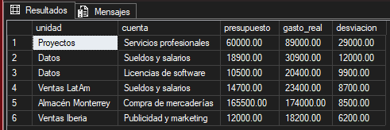

Ejercicio 9

CREATE OR ALTER VIEW dbo.vw_riesgo_cliente AS
WITH cobros_factura AS (
-- CTE 1 Suma los cobros por factura
SELECT factura_id,
SUM(importe) AS total_cobrado
FROM dbo.cobros
GROUP BY factura_id
),
detalle_facturas AS (
-- CTE 2 Calcula el saldo pendiente y el saldo vencido de cada factura
SELECT f.cliente_id,
f.importe - COALESCE(cf.total_cobrado, 0) AS pendiente,
CASE
WHEN f.fecha_vencimiento < '2026-09-30' AND (f.importe - COALESCE(cf.total_cobrado, 0)) > 0
THEN f.importe - COALESCE(cf.total_cobrado, 0)
ELSE 0
END AS vencido
FROM dbo.facturas AS f
LEFT JOIN cobros_factura AS cf ON cf.factura_id = f.factura_id
)
SELECT cl.cliente_id,
cl.razon_social,
cl.rating,
cl.limite_credito,
COALESCE(SUM(df.pendiente), 0) AS exposicion,
COALESCE(SUM(df.vencido), 0) AS saldo_vencido
FROM dbo.clientes AS cl
LEFT JOIN detalle_facturas AS df ON df.cliente_id = cl.cliente_id
GROUP BY cl.cliente_id, cl.razon_social, cl.rating, cl.limite_credito;
GO

SELECT razon_social,
rating,
limite_credito,
exposicion,
saldo_vencido
FROM dbo.vw_riesgo_cliente
WHERE exposicion > limite_credito
ORDER BY exposicion DESC;

Resultado
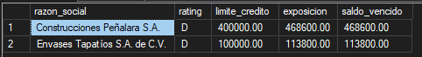

Ejercicio 10

DROP TABLE IF EXISTS dbo.facturas_2026_t3;

select *
into dbo.facturas_2026_t3
from facturas as f
where f.fecha_emision between '2026-07-01' and '2026-09-30';

select count(*) as facturas ,
SUM(importe) as importe_total ,
min(fecha_emision) as primera_emision,
max(fecha_emision) as ultima_emision

from dbo.facturas_2026_t3

Resultado


Ejercicio 11
DROP TABLE IF EXISTS dbo.facturas_enriquecidas;

SELECT f.factura_id,
cl.razon_social,
cl.pais,
f.fecha_emision,
f.importe,
COALESCE(co.total_pagado, 0) AS pagado,
f.importe - COALESCE(co.total_pagado, 0) AS pendiente
INTO dbo.facturas_enriquecidas
FROM dbo.facturas AS f
LEFT JOIN dbo.clientes AS cl ON f.cliente_id = cl.cliente_id
LEFT JOIN (
SELECT factura_id, SUM(importe) AS total_pagado
FROM dbo.cobros
GROUP BY factura_id
) AS co ON f.factura_id = co.factura_id;

SELECT CASE
WHEN pagado = 0 THEN N'Sin cobro'
WHEN pagado < importe THEN N'Cobro parcial'
ELSE N'Cobrada'
END AS estado_cobro,
COUNT(*) AS facturas,
SUM(importe) AS importe,
SUM(pendiente) AS pendiente
FROM dbo.facturas_enriquecidas
GROUP BY CASE
WHEN pagado = 0 THEN N'Sin cobro'
WHEN pagado < importe THEN N'Cobro parcial'
ELSE N'Cobrada'
END
ORDER BY facturas DESC;

Resultado

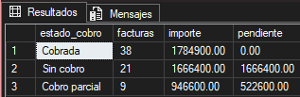

Pregunta 12

DROP TABLE IF EXISTS #cobros_t3;

SELECT co.cobro_id,
cl.razon_social,
co.fecha_cobro,
co.importe,
co.metodo
INTO #cobros_t3
FROM dbo.cobros AS co
JOIN dbo.facturas AS f ON f.factura_id = co.factura_id
JOIN dbo.clientes AS cl ON cl.cliente_id = f.cliente_id
WHERE co.fecha_cobro BETWEEN '2026-07-01' AND '2026-09-30';
GO

SELECT metodo,
COUNT(*) AS cobros,
SUM(importe) AS importe_cobrado
FROM #cobros_t3
GROUP BY metodo
ORDER BY importe_cobrado DESC;
GO

SELECT TOP 3
razon_social,
SUM(importe) AS importe_cobrado
FROM #cobros_t3
GROUP BY razon_social
ORDER BY importe_cobrado DESC;

Resultado
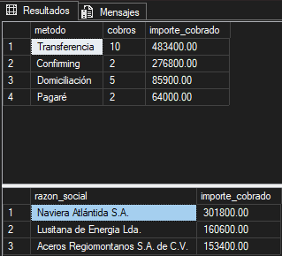

Pregunta 13
DROP TABLE IF EXISTS #lote_unico;
SELECT DISTINCT cobro_id,
factura_id,
fecha_cobro,
importe,
metodo
INTO #lote_unico
FROM dbo.stg_cobros;

DROP TABLE IF EXISTS #lote_valido;
SELECT u.cobro_id,
u.factura_id,
u.fecha_cobro,
u.importe,
u.metodo
INTO #lote_valido
FROM #lote_unico AS u
WHERE NOT EXISTS (
SELECT 1 FROM dbo.cobros AS c WHERE c.cobro_id = u.cobro_id
)
AND EXISTS (
SELECT 1 FROM dbo.facturas AS f WHERE f.factura_id = u.factura_id
)
AND u.importe > 0;

SELECT etapa, filas
FROM (
SELECT 'stg_cobros' AS etapa, COUNT(*) AS filas FROM dbo.stg_cobros
UNION ALL
SELECT '#lote_unico', COUNT(*) FROM #lote_unico
UNION ALL
SELECT '#lote_valido', COUNT(*) FROM #lote_valido
) AS t
ORDER BY filas DESC;

SELECT cobro_id,
factura_id,
fecha_cobro,
importe,
metodo
FROM #lote_valido
ORDER BY cobro_id ASC;

Resultado

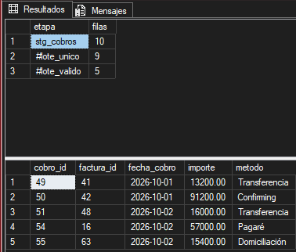

Ejercicio 14

WITH arbol_empleados AS (
-- Caso base
SELECT empleado_id,
nombre,
puesto,
0 AS nivel
FROM dbo.empleados
WHERE nombre = N'Álvaro Montes'

UNION ALL

-- Caso recursivo
SELECT e.empleado_id,
e.nombre,
e.puesto,
a.nivel + 1
FROM dbo.empleados AS e
JOIN arbol_empleados AS a ON e.jefe_id = a.empleado_id
)
SELECT nombre,
puesto,
nivel
FROM arbol_empleados
WHERE nivel > 0
ORDER BY nivel ASC, nombre ASC;

Resultato
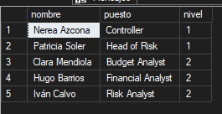

Pregunta 15
DROP TABLE IF EXISTS dbo.cierre_cobros_2026_t3;

SELECT cl.cliente_id,
cl.razon_social,
SUM(co.importe) AS importe_cobrado,
CAST('2026-09-30' AS DATE) AS fecha_foto
INTO dbo.cierre_cobros_2026_t3
FROM dbo.clientes AS cl
JOIN dbo.facturas AS f ON f.cliente_id = cl.cliente_id
JOIN dbo.cobros AS co ON co.factura_id = f.factura_id
WHERE co.fecha_cobro <= '2026-09-30'
GROUP BY cl.cliente_id, cl.razon_social;
GO

SELECT cliente_id,
razon_social,
importe_cobrado,
fecha_foto
FROM dbo.cierre_cobros_2026_t3
ORDER BY importe_cobrado DESC;

Resultado
